Weaved IoT Kit

Access your Pi over the Internet and say goodbye to port-forwarding.

By Eric PTAK

Creator of WebIOPi

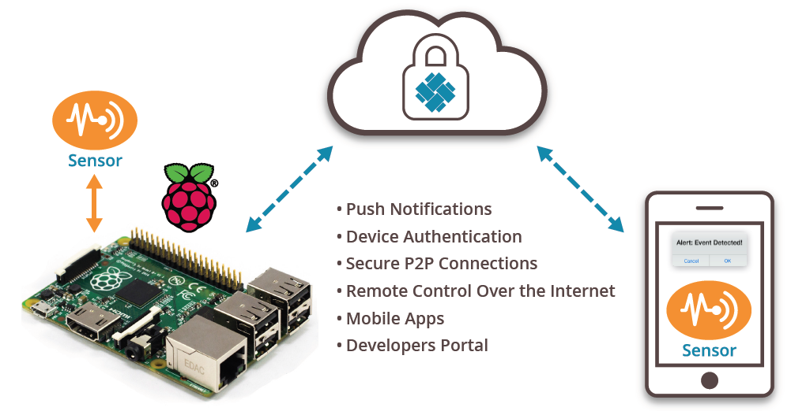

Ever since I released WebIOPi in 2012, I have often received messages about accessing the Pi over the Internet.

The problem is that the Pi is connected to Internet with a home-router that shares a single public IP for all your devices. If you want to access your Pi from – let say – a friend’s house, you need to connect to your own public IP. Your own router then doesn’t know which device you are trying to access.

Basically, you have to setup port-forwarding on your home router, but that depends on the router. Every router is different and it’s impossible to provide a set of unique instructions that will suit everyone.

Once you have setup port-forwarding, you will realize that your public IP can also change, so you will then need some dynamic DNS.

Each step required is accessible to everyone, but it can take a lot of time you can spend more productively.

I recently discovered the IoT Kit from Weaved Inc., a start up in the Silicon-Valley.

Weaved provides a free, secure, easy-to-use and efficient way to access your device from anywhere. Just install the Weaved IoT Kit to access your Pi via the Weaved web portal or mobile application.

1. Ensure the service (WebIOPi, Apache, SSH…) you want to access is running and working on your Pi.
2. Create an account for free on https://developer.weaved.com/
3. Download the Weaved IoT Kit installer on your Pi using a terminal window or SSH connection:

$ wget https://github.com/weaved/installer/raw/master/binaries/weaved-nixinstaller_1.2.x.bin

Where “1.2.x” is the latest version of the installer software on the Weaved website.

1. Make the installer executable:

chmod +x weaved-nixinstaller_1.2.x.bin

1. Run the installer:

sudo ./weaved-nixinstaller_1.2.x.bin

1. Log into the installer using the account you created at step 2.
2. Choose the service you want to access, it can be either Apache, SSH, WebIOPi or a custom service.

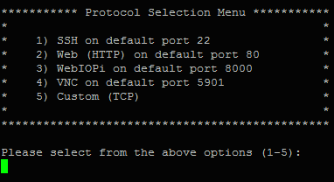

1. Enter an alias to identify your device and service; the installer will register your device, which can take a while.
2. Connect to your device via https://developer.weaved.com/ or download the Weaved free iOS application. That’s it; you’re done; no complex configuration.

